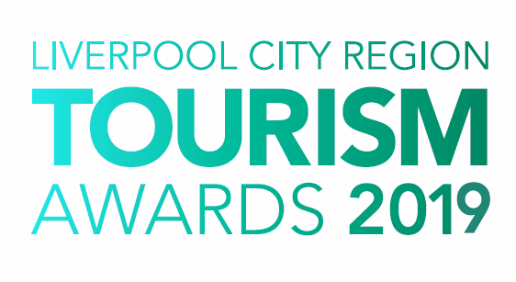

Tourism Experience
of the Year

Who can enter?

This award is for businesses offering an experience that relates to a specific activity, or special package offering with a substantial appeal to visitors to Liverpool City Region. Entries are invited from any tourism enterprise that provides an outstanding, unique experience for its visitors. Experiences can include specialist tours, trails, exhibitions and themed days out.

Entrants will demonstrate innovation and a sense of distinctiveness that make them stand out. It should be noted that supporting evidence in the submissions for this category is particularly important.

Judging

- The first stage of judging is based on your entry forms. A panel of judges will review entries and draw up a shortlist.

- The second stage judging panel will convene to select winners from the shortlist, taking account of your original entry, first stage judging reports, any mystery visits or interviews, along with your supporting evidence and website/social media. Particular attention will be paid to user generated content on sites such as Trip Advisor.

- Feedback is available on request however judges’ decisions are final.

Supporting Evidence

Evidence to support your entry will be required ONLY if you are shortlisted. Successful businesses will be contacted with information on submitting evidence once the first round of judging has taken place.

Next Steps
Please complete the application form and email to the address below as soon as possible, but no later than 5pm on Friday 18th January 2019.

By entering the Awards, you agree to be part of any publicity undertaken in association with the Awards. Furthermore, if selected as a finalist, you accept and agree that LCR Tourism Awards may use or publish any photographs, comments or evidence submitted at any stage in the Awards programme in any media waiving any rights to payment or to inspect and approve a finished product.

Winners will be announced at a glittering award ceremony, which will take place on Thursday 16th May 2019. Attended by over 500 tourism leaders and businesses, the 2019 annual tourism awards dinner and ceremony provides an ideal opportunity to network with industry professional and to celebrate your business achievements.

Reserve your place(s) now by emailing tourismawards@eventfulonline.com or call 0844 809 4399 for more details. Tickets are priced at £100 + vat for LEP members and £110 + vat Non LEP members. An ‘Early Bird’ offer is available at £90 + vat for LEP members and £100 + vat for Non LEP members. Tickets must be booked and paid for in full before 1st April 2019 to benefit from this offer.

Good luck with your entry and we look forward to seeing you at the event.

Eventful Events Team
T : 0844 809 4399 | M : 07484 047361 | E : tourismawards@eventfulonline.com
Tourism Experience of the Year

The answers to the following questions form the basis of your submission to the Liverpool City Region Tourism Awards 2019.

Business Information

Contact Details
Contact Name:
Business Name:
Business Type:
Event Name:
Business Address:
Telephone:
Mobile:
Email:
Website:
Social Media User Names:
*PR Contact Details
(if different from above)
(Please include name and contact details)

*If a PR contact is provided all communications regarding your entry will be directed via the contact name and details you provide.

Business Details
How long has the experience been operating? | Years |  | Months
How many staff do you employ?  (Include proprietors/owners) | Full Time | Part Time |  | Seasonal
Please provide of any details of any periods, whereby the experience does not open:

Visitor Details
These dates are used to allow full year’s figures to be included: | Last 12 Months  (i.e. Jan to Dec 2018) |  | Previous 12 Months  (i.e. Jan to Dec 2018)
Please indicate your visitor numbers over the last two years:
Types of visitors:  (Please indicated numbers in each category) | Local | National |  | International

Previous Awards
Please list all Awards in the last 12 months
Title of Award | Level (e.g. Gold) | Awarding Organisation | Year

Provide a brief outline of your experience (max 50 words)

Please answer the following questions in full considering the word count for each. The judges will score against each question.

1. Developing the Concept (max 300 words)
Please provide details of how the activity/concept was developed, from identification of the market to how it was developed, tested and marketed.
Please include details of any evaluation measures that have been put in place.

2. Commitment to Excellence (max 300 words)
Define the unique selling point(s) of your business.
How has your business achieved excellence in the last 12 months either through improving your facilities or your guest/visitor experience?

3. Outstanding Customer Service (max 300 words)

Describe how you provide an excellent customer experience.
This can be from enquiries and bookings, through to guest welcome/arrival including your approach to complaint handling. Please give examples. How does this impact on your business, e.g. increase in positive customer comments.

4. Staff Training and Development (max 300 words)

What investment have you made in staff training and development in the last 12 months?

Please state the training provided across all areas and the number of staff it involved. What impact has this had on your business?

5. Innovative/Creative Marketing (max 300 words)

What innovative or creative marketing have you implemented in the last 12 months and how has this impacted your business?

Please state your target markets and your approach to digital marketing and social media.

6. Sustainable and Accessible Tourism (max 150 words each)

How do you approach sustainability and accessibility within your business?
Please consider accessible facilities do you offer to guests/visitors and how do you promote them? How do you support the local economy (e.g using local produce, employing locally and what are your green credentials (e.g managing energy, waste and water consumption).

- Additional Information (max 200 words)

Please sum up why you think your business should win this award

