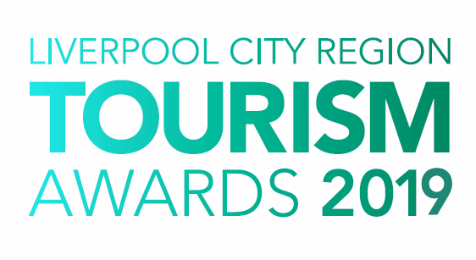

Restaurant of the Year

Who can enter?

This category is open to restaurants (including hotel restaurants) within the Liverpool City Region that have been trading for more than 6 months in 2018.

Entrants to this award should offer a full dining experience including table service.

The award aims to reward tourism businesses that produce or prepare food or drink products and, where possible, source local produce and ingredients contributing to the long-term sustainability of their local community.

Cafes, tea-rooms, food halls and individual street food outlets should enter the Café of the Year category.

Judging

- The first stage of judging is based on your entry forms. A panel of judges will review entries and draw up a shortlist.

- Short-listed establishments will receive an unannounced visit and applicants for this category must be willing to reimburse for the visit. You will be invoiced for the total amount after the visit.

- The second stage judging panel will convene to select winners from the shortlist, taking account of your original entry, first stage judging reports, any mystery visits or interviews, along with your supporting evidence and website/social media. Particular attention will be paid to user generated content on sites such as Trip Advisor.

- Feedback is available on request however judges’ decisions are final.

Supporting Evidence
Evidence to support your entry will ONLY be required if you are shortlisted. Successful businesses will be contacted with information on submitting evidence once the first round of judging has taken place.

Next Steps
Please complete the application form and email to the address below as soon as possible, but no later than 5pm on Friday 18th January 2019.

By entering the Awards, you agree to be part of any publicity undertaken in association with the Awards. Furthermore, if selected as a finalist, you accept and agree that LCR Tourism Awards may use or publish any photographs, comments or evidence submitted in the Awards programme, or in any other media, waiving any rights to payment or to inspect and approve a finished product.

Winners will be announced at a glittering award ceremony, which will take place on Thursday 16th May 2019. Attended by over 500 tourism leaders and businesses, the 2019 annual tourism awards dinner and ceremony provides an ideal opportunity to network with industry professional and to celebrate your business achievements.

Reserve your place(s) now by emailing tourismawards@eventfulonline.com or call 0844 809 4399 for more details. Tickets are priced at £105 +vat for LEP members and £115 +vat Non LEP members. (An ‘Early Bird’ offer is available at £90 +vat for LEP members and £100 +vat for Non LEP members. Tickets must be booked and paid for in full before 31st March 2019 to benefit from this offer).

Good luck with your entry and we look forward to seeing you at the event.

Eventful Events Team
T : 0844 809 4399 | M : 07484 047361 | E : tourismawards@eventfulonline.com
Restaurant of the Year

The answers to the following questions form the basis of your submission to the Liverpool City Region Tourism Awards 2019.

Business Information

Contact Details
Contact Name:
Business/Property Name:
Business Type:
Business Address:
Telephone:
Mobile:
Email:
Website:
Social Media User Names:
*PR Contact Details
(If different from above)
(Please include name and
contact details)

* If a PR contact is provided all communications regarding your entry will be directed via the contact name and details you provide

Business Details
How long has the business been operating? | Years |  | Months
How many staff do you employ?  (Include proprietors/owners) | Full Time | Part Time |  | Seasonal
Type of cuisine:
Number of seats/covers:

Please note: You will be required to ‘waive the bill’ on the judges’ mystery shop visit (maximum 2 people), as set out in the judging process and guidance notes. If you would like to put a monetary limit on the bill, please state: | Limit | No Limit

Previous Awards
Please list all Awards in the last 12 months
Title of Award | Level (e.g. Gold) | Awarding Organisation | Year

Provide a brief outline of your establishment (max 50 words)

Please answer the following questions in full considering the word count for each. The judges will score against each question.

- Commitment to Excellence (max 200 words)

Define your unique selling point of your business.

How has your business achieved excellence in the last 12 months either through improving your facilities or your guest/visitor experience?

- Outstanding Customer Service (max 200 words)
Describe how you provide an excellent customer experience.
This can be from enquiries and bookings, through to guest welcome/arrival including your approach to complaint handling. Please give examples. How does this impact on your business, e.g. increase in positive customer comments.

3. Staff Training and Development (max 300 words)

What investment have you made in staff training and development in the last 12 months?

Please state the training provided across all areas and the number of staff it involved. What impact has this had on your business?

4. Innovative/Creative Marketing (max 300 words)

What innovative or creative marketing have you implemented in the last 12 months and how has this impacted your business?

Please state your target markets and your approach to digital marketing and social media.

5. Sourcing Quality Products (max 200 words)

Describe any quality systems you have in place for ensuring that the end products are of the highest quality.

How do you benchmark/measure the quality of the products you use? Give details of how you source your products and your criteria for sourcing suppliers? (please state the names of suppliers, where appropriate).

6. Sustainable and Accessible Tourism (max 150 words each)

How do you approach sustainability and accessibility within your business?
Please consider accessible facilities do you offer to guests/visitors and how do you promote them? How do you support the local economy (e.g. employing locally) and what are your green credentials (e.g. managing energy, waste and water consumption).

- Additional Information (max 200 words)

Please sum up why you think your business should win this award.

