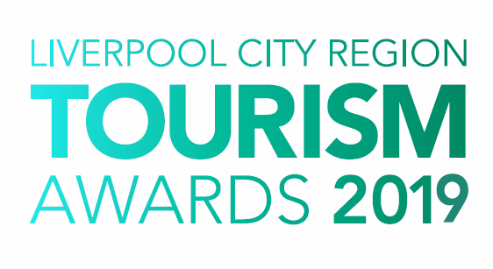

Best Newcomer to the
Visitor Economy

Who can enter?

This award recognises a new business that has been operating for 12 months or less during 2018. The focus of the business should clearly be around the visitor economy.

They should demonstrate quality, excellence and the impact they have made on the visitor economy in the Liverpool City Region through the business, or personal offering.

Examples of businesses include (but not limited to) accommodation providers, restaurants, bars, retail, visitor attractions and tours.

Judging

- The first stage of judging is based on your entry forms. A panel of judges will review entries and draw up a shortlist.

- The second stage judging panel will convene to select winners from the shortlist, taking account of your original entry, first stage judging reports, any mystery visits or interviews, along with your supporting evidence and website/social media. Particular attention will be paid to user generated content on sites such as Trip Advisor.

- Feedback is available on request; however, judges’ decisions are final.

Supporting Evidence
Evidence to support your entry will ONLY be required if you are shortlisted. Successful businesses will be contacted with information on submitting evidence once the first round of judging has taken place.

Next Steps
Please complete the application form and email to the address below as soon as possible, but no later than 5pm on Friday 18th January 2019.

By entering the Awards, you agree to be part of any publicity undertaken in association with the Awards. Furthermore, if selected as a finalist, you accept and agree that LCR Tourism Awards may use or publish any photographs, comments or evidence submitted at any stage in the Awards programme in any media waiving any rights to payment or to inspect and approve a finished product.

Winners will be announced at a glittering award ceremony, which will take place on Thursday 16th May 2019. Attended by over 500 tourism leaders and businesses, the 2019 annual tourism awards dinner and ceremony provides an ideal opportunity to network with industry professionals and to celebrate your business achievements.

Reserve your place(s) now by emailing tourismawards@eventfulonline.com or call 0844 809 4399 for more details. Tickets are priced at £100 + vat for LEP members and £110 + vat Non LEP members. An ‘Early Bird’ offer is available at £90 + vat for LEP members and £100 + vat for Non LEP members. Tickets must be booked and paid for in full before 1st April 2019 to benefit from this offer.

Good luck with your entry and we look forward to seeing you at the event.

Eventful Events Team
T : 0844 809 4399 | M : 07484 047361 | E : tourismawards@eventfulonline.com

Best Newcomer to the Visitor Economy

The answers to the following questions form the basis of your submission to the Liverpool City Region Tourism Awards 2019.

Business Information

Contact Details
Contact Name:
Business /Property Name:
Business Type:
Address:
Telephone:
Mobile:
Email:
Website:
Social Media User Names:
*PR Contact Details
(If different from above)
(Please include name and contact details)

*If a PR contact is provided all communications regarding your entry will be directed via the contact name and details you provide.

Business Details
How long has the business or individual been operating: | Months
How many staff do you employ?  (Include proprietors/owners) | Full Time | Part Time | Seasonal

Previous Awards
Please list any Awards you have achieved in your first year of operation
Title of Award | Level (e.g. Gold) | Awarding Organisation | Year

Provide a brief outline of the business or individual (max 200 words)

Please answer the following questions in full, considering the word count for each. The judges will score against each question.

1. Describe how your business has impacted positively on the tourism industry in Liverpool City Region. (max 300 words)

e.g. demonstrating your commitment to excellence and customer service.

2. Describe how you have raised awareness of the business since starting up. (max 300 words)

Please consider the following:
- Successful marketing initiatives including any early evidence of the impact this has had on your business.
- Target market and how the product/service fits the audience.
- Your approach to digital and social media.
- How have you particularly targeted visitors to the City Region?

3. Staff Training and Development (max 300 words)

Describe your approach to staff training and development.

What investment have you made in staff training and development in the last 12 months?

Please state the training provided across all areas and the number of staff it involved. What impact has this had on your business?

4. Sustainable and Accessible Tourism (max 150 words each)

How do you approach sustainability and accessibility within your business?
Please consider accessible facilities do you offer to guests/visitors and how do you promote them? How do you support the local economy (e.g using local produce, employing locally) and what are your green credentials (e.g managing energy, waste and water consumption).

5. Describe your aspirations for the future. How do you see your business growing in the next 5 years?
(max 200 words)

6. Why do you think you are the Best Newcomer to the visitor economy in
Liverpool City Region? (max 200 words)

