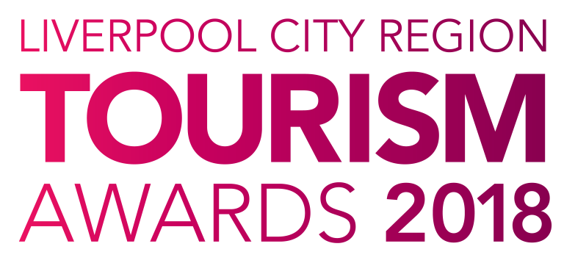

Tourism Star (s)
of the Year

Who can enter?

This award recognises dedication and commitment to excellence in the tourism, leisure and hospitality industry by an individual or a team. The recipient(s) should demonstrate an outstanding approach to customer service and have gained industry respect locally and regionally.

They must demonstrate excellent product knowledge of their own establishment and the local area. With strong communication skills, this individual or team will be a positive role model(s) and their job role must be 75% customer facing.

Winners of this category in the 2017 Liverpool City Region Tourism Awards are exempt from applying.

Judging

- Judges are looking for evidence of the impact made on the local economy and the level of customer service excellence provided by the individual or team.

- A Judging Panel, consisting of members of the Visitor Economy Board and members of the business community, will draw up an initial short-list from the entries received.

- Short-listed entrants will be invited to attend an interview with a small panel of judges.

- The information contained within this entry form along with the feedback from their interview will used to select a winner.

Next Steps

Please complete the application form and email to the address below as soon as possible, but no later than 5pm on Friday 12th January 2018.

By entering the Awards, you agree to be part of any publicity undertaken in association with the Awards. Furthermore, if selected as a finalist, you accept and agree that LCR Tourism Awards may use or publish any photographs, comments or evidence submitted in the Awards programme, or any media, waiving any rights to payment or to inspect and approve a finished product.

Winners will be announced at a glittering award ceremony, which will take place on Thursday 24th May 2018. Attended by over 500 tourism leaders and businesses, the 2018 annual tourism awards dinner and ceremony provides an ideal opportunity to network with industry professional and to celebrate your business achievements.

Reserve your place(s) now by emailing tourismawards@eventfulonline.com or call 0844 809 4399 for more details. Tickets are priced at £100 + vat for LEP members and £110 + vat Non LEP members. An ‘Early Bird’ offer is available at £90 + vat for LEP members and £100 + vat for Non LEP members. Tickets must be booked and paid for in full before 31st March 2018 to benefit from this offer.

Good luck with your entry and we look forward to seeing you at the event.

Eventful Events Team
T : 0844 809 4399 | M : 07484 047361 | E : tourismawards@eventfulonline.com
Tourism Star (s) of the Year

The answers to the following questions form the basis of your submission to the Liverpool City Region Tourism Awards 2018.

Nominees Contact Details
Name:
Place of work:
Role:
Job title:
Address:
Telephone:
Mobile:
Email:

Your Contact Details
Name:
Place of Work:
Job Title:
Address:
Telephone:
Mobile:
Email:
Website

Please confirm if the nominee is aware of this nomination: | Yes | No

Please answer the following questions in full considering the word count for each. The judges will score against each question.

1. Please briefly describe the nominee(s) role/current position. (max 50 words)

2. How long has the nominee(s) been in the organisation and what type of customer service activity do they undertake? (max 300 words)
Nominees daily activities should be made up of at least 75% customer facing duties.

3. In what way has the nominee(s) exceeded customer’s expectations in their role in the last 12 months and how do they inspire colleagues. (max 250 words)
e.g. do they regularly receive positive customer feedback, do they go above and beyond their role to provide excellent customer service, do they receive recognition from employers and peers, how do they show initiative and creativity?

4. Explain and give examples of how they work well in a team environment and/or proactively alone. (max 250 words)

5. Explain why they are deserving of this award. (max 250 words)

