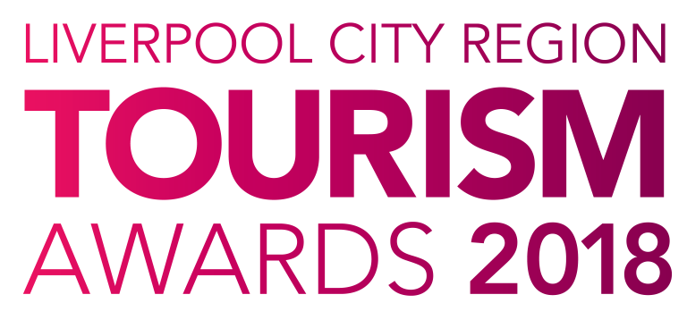

Small Tourism Event
of the Year

Who can enter?

This award is open for any business organising an Event or Festival with an appeal to visitors to Liverpool City Region with less than 75,000 visitors. It may include an activity that takes place over a day(s), week(s), month, or season, and could encompass carnivals, shows, celebrations, air shows, festivals or events. Events can be either paid entry or free audience/attendance event. Entries are invited from any tourism enterprise that provides an outstanding, unique event for its visitors which took place in 2017.

Entries will demonstrate innovation and a sense of distinctiveness that make them stand out. It should be noted that supporting evidence in the submissions for this category is particularly important.

Judging

- The first stage of judging is based on your entry forms plus online reviews where available and your website. A panel of judges will review entries and draw up a shortlist.

- The second stage judging panel will convene to select winners from the shortlist, taking account of your original entry, first stage judging reports, any mystery visits or interviews, along with your supporting evidence. Particular attention will be paid to user generated content on sites such as Trip Advisor.

- Feedback is available on request however judges’ decisions are final.

Supporting Evidence
Evidence to support your entry will ONLY be required if you are shortlisted. Successful businesses will be contacted with information on submitting evidence once the first round of judging has taken place.

Next Steps
Please complete the application form and email to the address below as soon as possible, but no later than 5pm on Friday 12th January 2018.

By entering the Awards, you agree to be part of any publicity undertaken in association with the Awards. Furthermore, if selected as a finalist, you accept and agree that LCR Tourism Awards may use or publish any photographs, comments or evidence submitted in the Awards programme, or any other media, waiving any rights to payment or to inspect and approve a finished product.

Winners will be announced at a glittering award ceremony, which will take place on Thursday 24th May 2018. Attended by over 500 tourism leaders and businesses, the 2018 annual tourism awards dinner and ceremony provides an ideal opportunity to network with industry professional and to celebrate your business achievements.

Reserve your place(s) now by emailing tourismawards@eventfulonline.com or call 0844 809 4399 for more details. Tickets are priced at £100 + vat for LEP members and £110 + vat Non LEP members. An ‘Early Bird’ offer is available at £90 + vat for LEP members and £100 + vat for Non LEP members. Tickets must be booked and paid for in full before 31st March 2018 to benefit from this offer.

Good luck with your entry and we look forward to seeing you at the event.

Eventful Events Team
T : 0844 809 4399 | M : 07484 047361 | E : tourismawards@eventfulonline.com
Small Tourism Event of the Year

The answers to the following questions form the basis of your submission to the Liverpool City Region Tourism Awards 2018.

Business Information

Contact Details
Contact Name:
Business Name:
Business Type:
Event Name:
Business Address:
Telephone:
Mobile:
Email:
Website:
Social Media User Names:
*PR Contact Details
(if different from above)
(Please include name and contact details)

*If a PR contact is provided all communications regarding your entry will be directed via the contact name and details you provide.

Event Details
How long has the event been operating? | Years |  | Months
How many staff do you employ?  (Include proprietors/owners) | Full Time | Part Time |  | Seasonal
Please confirm the frequency of the event: | Annual | Biennial |  | One Off

Visitor Details
These dates are used to allow full year’s figures to be included: | Last 12 Months  (i.e. Jan to Dec 2017) |  | Previous 12 Months  (i.e. Jan to Dec 2016)
How many people have attended the event in the last 2 years?
Types of visitors:  (Please indicated numbers in each category) | Local | National |  | International

Previous Awards
Please list all Awards in the last 12 months
Title of Award | Level (e.g. Gold) | Awarding Organisation | Year

Provide a brief outline of your event (max 50 words)

Please answer the following questions in full considering the word count for each. The judges will score against each question.

- Developing the Concept (max 300 words)
Please provide details of how the activity/concept was developed, from identification of the market to how it was developed, tested and marketed.
Please include details of any evaluation measures that have been put in place.

2. Commitment to Excellence (max 300 words)
Define the unique selling point(s) of your business.
Please demonstrate your commitment to excellence. This includes investment of money and time to improve facilities, customer care and ultimately your visitor’s experience. Investment must have been made in the last two years.

3. Outstanding Customer Service (max 300 words)
Describe how you provide an excellent customer experience.
This can be from enquiries and bookings, through to guest welcome/arrival including your approach to complaint handling. Please give examples. How does this impact on your business, e.g. increase in positive customer comments, etc.?

4. Staff Training and Development (max 300 words)

What investment has been made in staff training and development within the last 12 months?

Please state training provided in all areas of the business including technical, service and product. Please state the number of staff that have taken part in the training. Do you have an on-going training plan in place? How has this added value to your business, the services to guests and satisfaction levels? Please include your part-time staff and proprietors if a family-run business.

5. Innovative/Creative Marketing (max 300 words)

What innovative marketing have you done to attract new and repeat business and what was the result?

Please consider the following:
- Successful marketing initiatives in the past 12 months including details and evidence of the impact on your business.
- Target market and how the product/service fits the audience.
- Your approach to digital and social media.
- Please demonstrate how success was measured.

6. Sustainable and Accessible Tourism (max 150 words each)

Have you made a significant and/or special contribution in the areas of Accessibility and Sustainability?
- Do you specialise in offering access to guests with particular needs?
- How do you support the local economy (e.g. local purchasing, local produce, employing local people, supporting other local businesses)?
- What are your ‘green credentials’? (managing energy, waste or water consumption)
- Describe how you communicate your efforts to make your business more sustainable and accessible and how you encourage guests and employees to get involved.

Accessibility Guide (Previously Access Statement)
Do you have an accessibility guide? | Yes | No
Is it available on your website? | Yes | No

7. Additional Information (max 200 words)

Please sum up why you think your business should win this award

