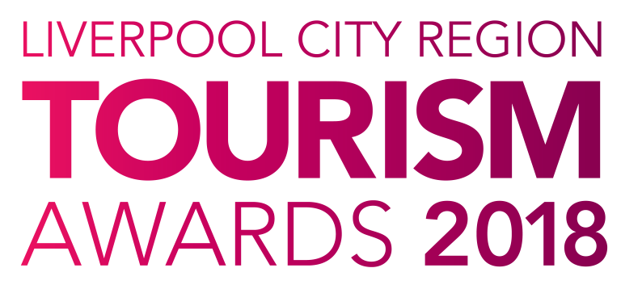

Best Newcomer to the
Visitor Economy

Who can enter?

This award recognises a business, or individual that has been operating (or in post) for 12 months or less during 2017.

They should demonstrate quality, excellence and their impact on the visitor economy in the Liverpool City Region through the business, or personal offering.

Judging

- The first stage of judging is based on your entry forms plus online reviews where available and your website. A panel of judges will review entries and draw up a shortlist.

- The second stage judging panel will convene to select winners from the shortlist, taking account of your original entry, first stage judging reports, any mystery visits or interviews, along with your supporting evidence. Particular attention will be paid to user generated content on sites such as Trip Advisor.

- Feedback is available on request; however, judges’ decisions are final.

Supporting Evidence
Evidence to support your entry will ONLY be required if you are shortlisted. Successful businesses will be contacted with information on submitting evidence once the first round of judging has taken place.

Next Steps
Please complete the application form and email to the address below as soon as possible, but no later than 5pm on Friday 12th January 2018.

By entering the Awards, you agree to be part of any publicity undertaken in association with the Awards. Furthermore, if selected as a finalist, you accept and agree that LCR Tourism Awards may use or publish any photographs, comments or evidence submitted at any stage in the Awards programme in any media waiving any rights to payment or to inspect and approve a finished product.

Winners will be announced at a glittering award ceremony, which will take place on Thursday 24th May 2018. Attended by over 500 tourism leaders and businesses, the 2018 annual tourism awards dinner and ceremony provides an ideal opportunity to network with industry professionals and to celebrate your business achievements.

Reserve your place(s) now by emailing tourismawards@eventfulonline.com or call 0844 809 4399 for more details. Tickets are priced at £100 + vat for LEP members and £110 + vat Non LEP members. An ‘Early Bird’ offer is available at £90 + vat for LEP members and £100 + vat for Non LEP members. Tickets must be booked and paid for in full before 31st March 2018 to benefit from this offer.

Good luck with your entry and we look forward to seeing you at the event.

Eventful Events Team
T : 0844 809 4399 | M : 07484 047361 | E : tourismawards@eventfulonline.com

Best Newcomer to the Visitor Economy

The answers to the following questions form the basis of your submission to the Liverpool City Region Tourism Awards 2018.

Business Information

Contact Details
Contact Name:
Business /Property Name:
Business Type:
Address:
Telephone:
Mobile:
Email:
Website:
Social Media User Names:
*PR Contact Details
(If different from above)
(Please include name and contact details)

*If a PR contact is provided all communications regarding your entry will be directed via the contact name and details you provide.

Business Details
How long has the business or individual been operating: | Years |  | Months
How many staff do you employ?  (Include proprietors/owners) | Full Time | Part Time |  | Seasonal

Previous Awards
Please list any Awards you have achieved in your first year of operation
Title of Award | Level (e.g. Gold) | Awarding Organisation | Year

Provide a brief outline of the business or individual (max 200 words)

Please answer the following questions in full, considering the word count for each. The judges will score against each question.

1. Describe how your business has impacted positively on the tourism industry in Liverpool City Region. (max 300 words)

e.g. demonstrating your commitment to excellence and customer service.

2. Briefly describe how you have raised awareness of the business or individual since starting up. (max 200 words)

Please consider the following:
- Successful marketing initiatives including any early evidence of the impact this has had on your business.
- Target market and how the product/service fits the audience.
- Your approach to digital and social media.

3. Staff Training and Development (max 300 words)

Describe your approach to staff training and development.

e.g. have you, or are you planning to implement staff training plans? Have you had any early indicators that staff training has impacted on your business. Please state the number of staff that have taken part in the training.

4. Sustainable and Accessible Tourism (max 150 words each)

Have you made a significant and/or special contribution in the areas of Accessibility and Sustainability?
- Do you specialise in offering access to guests with particular needs?
- How do you support the local economy (e.g. local purchasing, local produce, employing local people, supporting other local businesses)?
- What are your ‘green credentials’? (managing energy, waste or water consumption)
- Describe how you communicate your efforts to make your business more sustainable and accessible and how you encourage guests and employees to get involved.

Accessibility Guide (Previously Access Statement)
Do you have an accessibility guide? | Yes | No
Is it available on your website? | Yes | No

5. Describe your aspirations as an individual/business for the future.
(max 200 words)

6. Why do you think you are the Best Newcomer to the visitor economy in
Liverpool City Region? (max 300 words)

