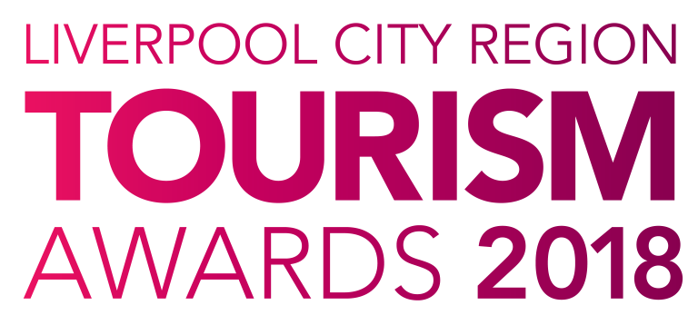

Bar/Pub of the Year

Who can enter?

This award is aimed at all nightlife venues including bars, public houses, nightclubs and hotel bars in the Liverpool City Region that has been trading for at least 6 months in 2017. The award winner will offer exceptional customer service and a memorable visitor experience. Businesses should describe the range of beverages on offer, as well as quality locally sourced food, where applicable.

Entrants should show innovation and a sense of distinctiveness that make them stand out. They should demonstrate consistent quality and creative marketing focused on visitors to the City Region.

Judging

- The first stage of judging is based on your entry forms plus online reviews where available and your website. A panel of judges will review entries and draw up a shortlist.

- Shortlisted establishments will receive an unannounced visit and applicants for this category must be willing to reimburse for the maximum of two drinks. You will be invoiced for the total amount after the visit.

- The second stage judging panel will convene to select winners from the shortlist, taking account of your original entry, first stage judging reports, any mystery visits or interviews, along with your supporting evidence. Particular attention will be paid to user generated content on sites such as Trip Advisor.

- Feedback is available on request however judges’ decisions are final.

Supporting Evidence
Evidence to support your entry will ONLY be required if you are shortlisted. Successful businesses will be contacted with information on submitting evidence once the first round of judging has taken place.

Next Steps
Please complete the application form to the email address below as soon as possible, but no later than 5pm on Friday 12th January 2018.

By entering the Awards, you agree to be part of any publicity undertaken in association with the Awards. Furthermore, if selected as a finalist, you accept and agree that LCR Tourism Awards may use or publish any photographs, comments or evidence submitted in the Awards programme, or any other media, waiving any rights to payment or to inspect and approve a finished product.

Winners will be announced at a glittering award ceremony, which will take place on Thursday 24th May 2018. Attended by over 500 tourism leaders and businesses, the 2018 annual tourism awards dinner and ceremony provides an ideal opportunity to network with industry professional and to celebrate your business achievements.

Reserve your place(s) now by emailing tourismawards@eventfulonline.com or call 0844 809 4399 for more details. Tickets are priced at £100 + vat for LEP members and £110 + vat Non LEP members. An ‘Early Bird’ offer is available at £90 + vat for LEP members and £100 + vat for Non LEP members. Tickets must be booked and paid for in full before 31st March 2018 to benefit from this offer.

Good luck with your entry and we look forward to seeing you at the event.

Eventful Events Team
T : 0844 809 4399 | M : 07484 047361 | E : tourismawards@eventfulonline.com
Bar of the Year

The answers to the following questions form the basis of your submission to the Liverpool City Region Tourism Awards 2018.

Business Information

Contact Details
Contact Name:
Business/Property Name:
Business Type:
Business Address:
Telephone:
Mobile:
Email:
Website:
Social Media User Names:
*PR Contact Details
(If different from above)
(Please include name and contact details)

*If a PR contact is provided all communications regarding your entry will be directed via the contact name and details you provide.

Business Details
How long has the business been operating? | Years |  | Months
How many staff do you employ?  (Include proprietors/owners) | Full Time | Part Time |  | Seasonal

Previous Awards
Please list all Awards in the last 12 months
Title of Award | Level (e.g. Gold) | Awarding Organisation | Year

Provide a brief outline of your establishment (max 50 words)
Give a brief history and description including range and nature of products, supply, and service. What makes your business special; warm welcome, atmospheric etc.

Please answer the following questions in full considering the word count for each. The judges will score against each question.

- Commitment to Excellence

Define the unique selling point(s) of your business. (max 300 words)
Please demonstrate your commitment to excellence. This includes investment of money and time to improve facilities, customer care and ultimately your guest’s experience. Investment must have been made in the last two years.

How do you promote sensible drinking policies? (max 100 words)

2. Outstanding Customer Service (max 300 words)
Describe how you provide an excellent customer experience.
This can be from enquiries and bookings, through to guest welcome/arrival including your approach to complaint handling. Please give examples. How does this impact on your business, e.g. increase in positive customer comments.

3. Staff Training and Development (max 300 words)

What investment has been made in staff training and development within the last 12 months?

Please state training provided in all areas of the business including technical, service and product. Please state the number of staff that have taken part in the training. Do you have an on-going training plan in place? How has this added value to your business, the services to guests and satisfaction levels? Please include your part-time staff and proprietors if a family-run business.

4. Innovative/Creative Marketing (max 300 words)

What innovative marketing have you done to attract new and repeat business and what was the result?

Please consider the following:
- Successful marketing initiatives in the past 12 months including details and evidence of the impact on your business.
- Target market and how the product/service fits the audience.
- Your approach to digital and social media.
- Please demonstrate how success was measured.

5. Sustainable and Accessible Tourism (max 150 words each)

Have you made a significant and/or special contribution in the areas of Accessibility and Sustainability?
- Do you specialise in offering access to guests with particular needs?
- How do you support the local economy (e.g. local purchasing, local produce, employing local people, supporting other local businesses)?
- What are your ‘green credentials’? (managing energy, waste or water consumption)
- Describe how you communicate your efforts to make your business more sustainable and accessible and how you encourage guests and employees to get involved.

Accessibility Guide (Previously Access Statement)
Do you have an accessibility guide? | Yes | No
Is it available on your website? | Yes | No

6. Food and Beverage (max 250 words)

Describe your menu offerings and what makes them special.

Please tell us about the food and drink offerings on your menu. Do you source from any local suppliers, cater for special diets, or offer imaginative dishes or beverages that are unique to your business?

- Additional Information (max 200 words)

Please sum up why you think your business should win this award.

